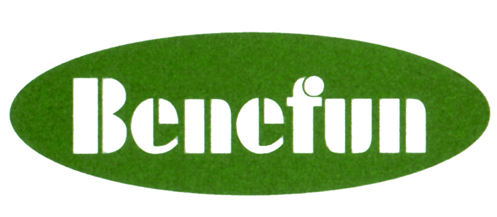
BENEFUN INTERNATIONAL HOLDINGS LIMITED
奮發國際控股有限公司 *
(Incorporated in Cayman Islands with limited liability)
(Stock Code: 1130)

DATE OF BOARD MEETING

The board of directors (the “Board”) of Benefun International Holdings Limited (“the Company”) announces that a meeting of the Board will be held on Wednesday, 22 October, 2008 for the purpose of approving, inter alia, the audited financial statements of the Company and its subsidiaries and the announcement of final results for the year ended 30 June, 2008.

For and on behalf of

Benefun International Holdings Limited
TAN Sim Chew

Chairman

Hong Kong, 10 October 2008

As at the date hereof, the Board comprises five executive directors, namely Mr. TAN Sim Chew, Mr. ZHONG Ma Ming, Mr. FU Zi Cong, Mr. LO King Fat, Lawrence and Mr. LEUNG Kwong Choi; and three independent non-executive directors, namely Mr. LI Chun Ming, Raymond, Mr. CHEUNG Ngai Lam and Mr. TSANG Chung Yu.

For identification only

